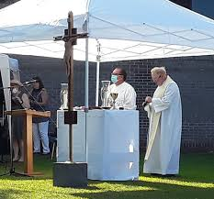

Outdoor Masses – What to Expect:

- Attendance is limited to 100. Any overflow will be seated in the hall (up to 70 people) where the mass can be watched via livestream (or heard through the window). Admittance will be on a first come first serve basis.

- Entrance will be through the main gate of the school. Handicap/Senior parking will be available in the school yard. Everyone else please park in the church lot or on the street.

- Everyone is asked to wear a mask and if possible bring your own hand sanitizer.

- Please bring your own chair. Benches will be available for seniors.

- Please check your temperature before coming and stay home if it is above 100.

- Communion will be distributed after mass is over. If you choose to watch mass at home or in your car, all are welcome to come to communion. Please follow the directions of the ushers as to where to receive.

