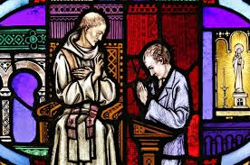

Outdoor Confession
(in the church parking lot at the shrine of Guadalupe)
Saturdays
3:00-4:00PM English And 5:30-6:30PM Spanish

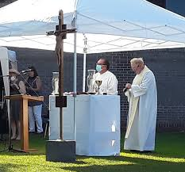

Outdoor Mass on the School Lawn
Saturdays
4:30PM English and 6:30PM Spanish
Sundays
8:30AM Spanish and 10:30AM English

Please bring your own chair and wear a mask.
Mass limited to 100.

