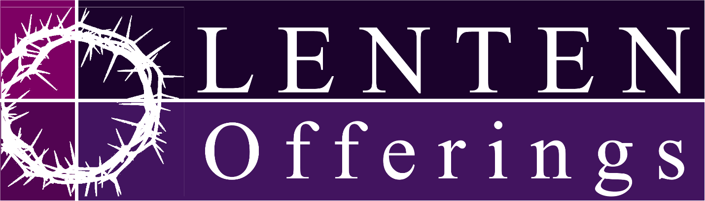
Adoration in the Church
Fridays from 9AM-6PM

Stations of the Cross in the Church
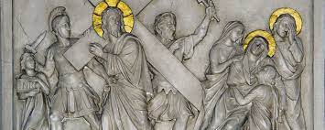
Fridays @ Noon in English
Fridays @ 6PM in Spanish

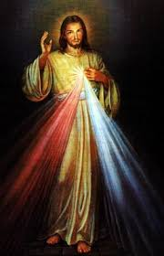
Divine Mercy Chaplet in the Church
Fridays @ 3PM Bilingual

Reconciliation
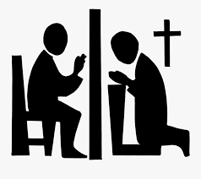
Fridays from 5-6PM – Spanish
Saturdays from 3-4PM – English
Saturdays from 5-6PM – Spanish

